Postgres command repo:

To connect the server through the psql in the command: 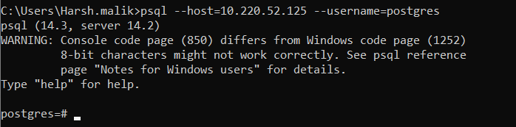

Now lets see the options that it does provide:

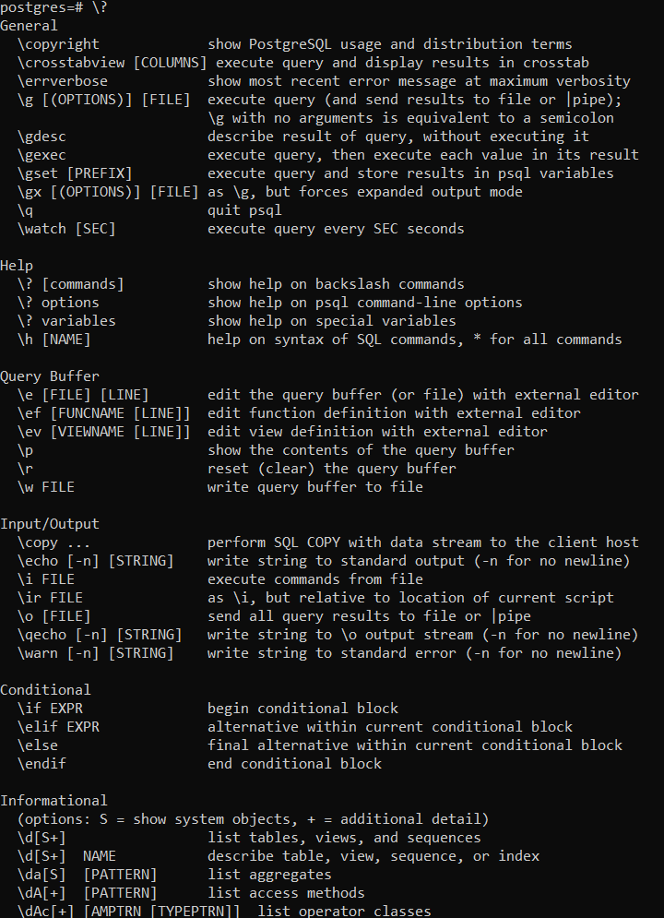

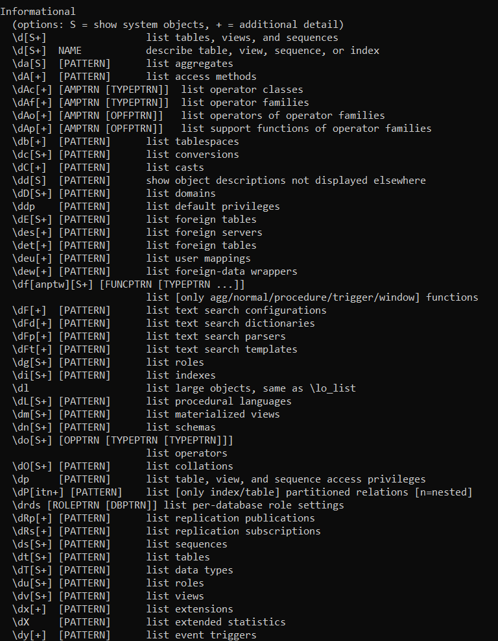

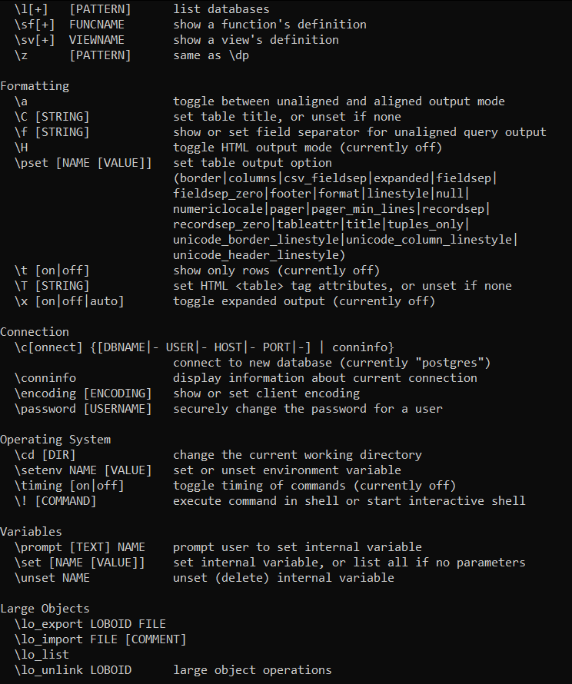

Theer are several datatypes oin postgres to handle a wide range of data byt at first numeric values:

INTEGER 4bytes

SMALLINT 2bytes

BIGINT 8bytes

DOUBLE PRECISION 8bytes

DECIMAL variable

NUMERIC variable

REAL 4 bytes

SERIAL 4 bytes

BIGSERIAL 8 bytes

Data and time

TIMESTAMP [with timezone] 8 bytes

TIMESTAMP [without timezone]8bytes

DATE 4bytes

TIME [without time] 8 bytes

INTERVAL 12 bytes

String types:

CHAR(size)

VARCHAR(size)

TEXT

CHARACTER(size)

CHARACTER VARYING(size)

Boolean

BOOLEAN 8bytes

Money

MONEY 8byte

Geometric

POINT 16byte

LINE 32byte

LSEG 32byte

BOX 32byte

PATH 16+16nbyte

POLYGON 40+16nbyte

CIRCLE 24byte

Lets see the databases in the server 10.220.52.125:

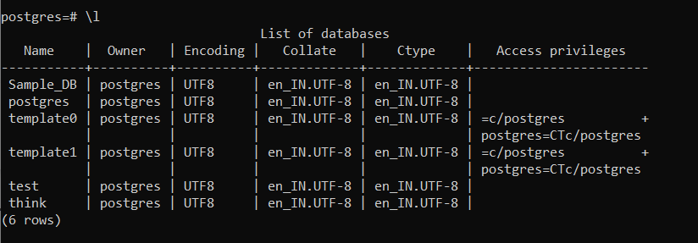

Creating a database

To make a database

CREATE DATABASE THINK;

We do have that already lets connect to it:

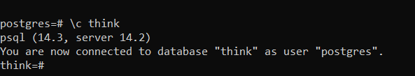

But lets just make another one:



But we don’t want it:



Lets create a schema in the database think that we are using

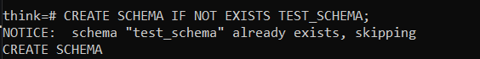

It already exists lets see what schemas we do have in our database:

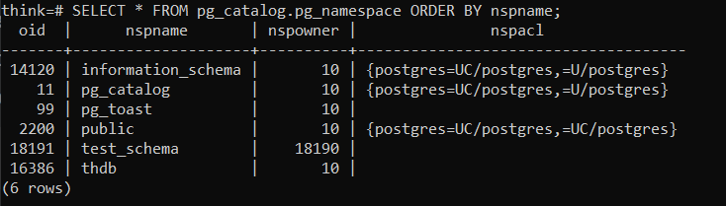

The number of the nspownwer is the owner id which is same as they all are maintained by postgres but test_schema is maintained by username harsh that’s why its id is different.

Lets make a relaton in our schema:

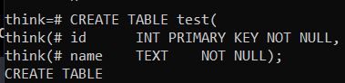

Lets check if it there:

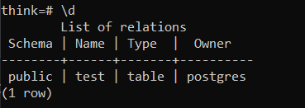

Its info

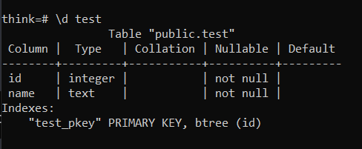

As you can see it is created in public schema but lets make this in our test_schema:

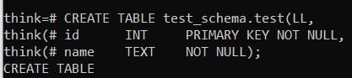

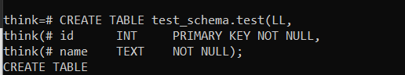

BUT WE CANT SEE ANYTHING BECAUSE,

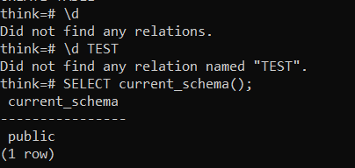

WE ARE IN THE PUBLIC SCHEMA ANDTEST_SCHEMA IS NOT IN THE SEARCH PATH OF THE POSTGRESQL TO FIX THIS I DID THIS;

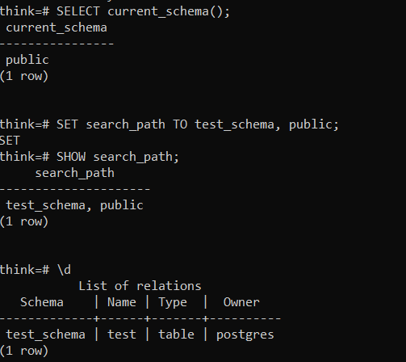

AND AS YOU CAN SEE THE TEST TABLE IN TEST_SCHEMA IS VISIBLE NOW;

lETS INSERT SOMETHIN IN OUR NEW TABLE:



LETS SEE OUR TABLE

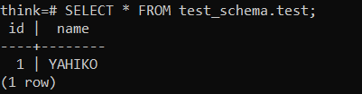

BUT I FORGOT TO ADD THE SURNAME :



I AM STILL WRONG:

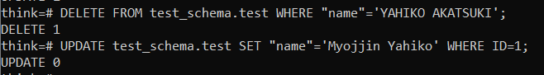

NOW IT IS RIGHT;